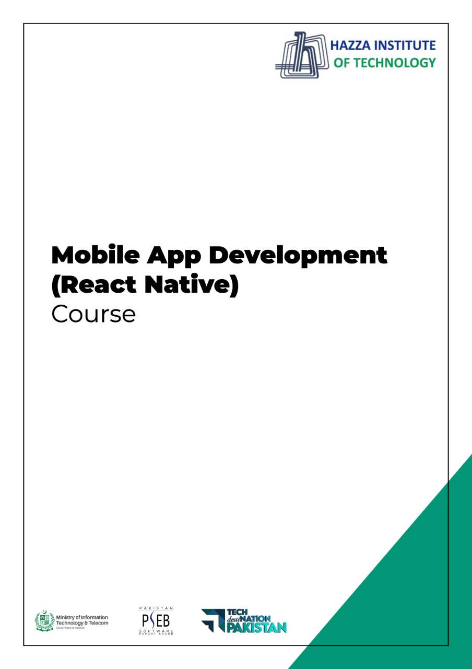

**(Flutter: Dart)**

Lab 2 (Session 2)

**Total Time:**

**3 hours (sessions-2)**

**Pre-Lab Activities:**

* + Familiar with dartpad for dart Editor
  + Student must complete Lab-2 session-1 before attempting these labs.

**Learning Outcomes:**

* + Demonstrate the knowledge of Dart OOP.

**Student Activities:**

* + Open Dartpad, and do advance exercise for dart

**Lab Tasks 1:**

Make a two-player Rock-Paper-Scissors game against computer.

Ask for player’s input, compare them, print out a message to the winner.

**Lab Tasks 2:**

Generate a random number between 1 and 100. Ask the user to guess the number, then tell them whether they guessed too low, too high, or exactly right.

**Lab Tasks 3:**

Ask the user for a number and determine whether the number is prime or not.

Do it using a function

**Lab Tasks 4:**

Write a program (function) that takes a list and returns a new list that contains all the elements of the first list minus all the duplicates

**Lab Tasks 5:**

Write a program (using functions!) that asks the user for a long string containing multiple words. Print back to the user the same string, except with the words in backwards order.

For example, say I type the string:

My name is Michele

Then I would see the string:

Michele is name My

**Lab Solutions:**

**LAB 2.1 :**

|  |
| --- |
| import 'dart:io';  import 'dart:math';  void main() {  print("Welcome to Rock, Paper, Scissors\nType 'exit' to stop the game");  final random = Random();  // Rules of the game  Map<String, String> rules = {  "rock": "scissors",  "scissors": "paper",  "paper": "rock"  };  // Initial score  int user = 0;  int comp = 0;  // Options for computer to choose  List<String> options = ["rock", "paper", "scissors"];  // Actual game  while (true) {  String compChoice = options[random.nextInt(options.length)];  stdout.write("\nPlease choose Rock, Paper or Scissors: ");  String userChoice = stdin.readLineSync().toLowerCase();  if (userChoice == "exit") {  print("\nYou: $user Computer: $comp\nBye Bye!");  break;  }  if (!options.contains(userChoice)) {  print("Incorrect choice");  continue;  } else if (compChoice == userChoice) {  print("We have a tie!");  } else if (rules[compChoice] == userChoice) {  print("Computer wins: $compChoice vs $userChoice");  comp += 1;  } else if (rules[userChoice] == compChoice) {  print("You win: $userChoice vs $compChoice");  user += 1;  }  }  } |

**LAB 2.2 :**

|  |
| --- |
| import 'dart:io';  import 'dart:math';  void main() {  print("Type exit to quit the game");  guessingGame();  }  guessingGame() {  final random = Random();  int randNumber = random.nextInt(100);  int attempt = 0;  while (true) {  attempt += 1;  stdout.write("Please choose a number between 0 and 100: ");  String chosenNumber = stdin.readLineSync();  // Make sure user does not go out of limits  if (chosenNumber.toLowerCase() == "exit") {  print("\nBye");  break;  } else if (int.parse(chosenNumber) > 100) {  print("Please do not go over 100");  continue;  }  // Main logic  if (int.parse(chosenNumber) == randNumber) {  print("Bingo! You tried $attempt times\n");  continue;  } else if (int.parse(chosenNumber) > randNumber) {  print("You are higher");  continue;  } else {  print("You are lower");  continue;  }  }  } |

**LAB 2.3 :**

|  |
| --- |
| import 'dart:io';  void main() {  stdout.write("Please give us a number: ");  int chosenNumber = int.parse(stdin.readLineSync());  checkPrime(chosenNumber);  }  void checkPrime(int number) {  // List comprehensions  List<int> a = [  for (var i = 1; i <= number; i++)  if (number % i == 0) i  ];  // Check for prime  a.length == 2  ? print("The chosen number is a prime")  : print("The chosen number is not a prime");  } |

**LAB 2.4 :**

|  |
| --- |
| import 'dart:math';  void main() {  final random = Random();  List<int> randList = List.generate(10, (_) => random.nextInt(10));  print("Initial list is $randList\n");  print("Cleaned list is ${removeDuplicates(randList)}");  }  List<int> removeDuplicates(List<int> initialList) {  return initialList.toSet().toList();  } |

**LAB 2.5 :**

|  |
| --- |
| import 'dart:io';  void main() {  stdout.write("Please give a sentence: ");  String sentence = stdin.readLineSync();  reverseSentence(sentence);  }  void reverseSentence(String sentence) {  /* Split the sentence into a list of words  Reverse the list, then join the words back */  String a = sentence.split(" ").reversed.toList().join(" ");  print(a);  } |